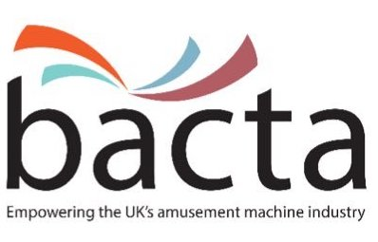

Press Release
Player Diaries: New Player Protection Tool from bacta

Bacta is proud to launch its ‘player diary’ this month, a new and additional tool to help members to increase positive customer interaction on the subject of responsible gambling.

Since 2018, bacta has been evaluating the potential value of ‘player diaries’ in AGCs as an additional Social Responsibility tool for customers who may wish to use them. The concept is based upon research that suggests players who monitor their play are better able to control their spend and avoid financial harm associated with their gambling.

“Our evaluation has demonstrated that while this is not for everyone, some players have said they found value in the diary. It also provides another optional tool for our members’ staff to discuss with customers, if they do have an interaction with them based upon their play,” says Simon Bradbury, Head of Social Responsibility and Compliance at bacta.

Player diaries also include essential safer gambling information with details on limited exposure, self-exclusion and signposting. The low-cost paper option compliments the use of other gambling management apps such as Gamblewise/Playright and assists bacta with its engagement around the National Responsible Gambling Strategy; in particular providing evidence of impact for activity and priority actions including evaluation.

The diaries allow customers to record and reflect on their gambling transactions over a 9- week period. This time period was established as it gave the player time enough to reflect on information recorded and sat nicely as a compact diary.

A pilot period took place over a 3-month period June – August 2019. A number of arcade operators were provided with over 500 diaries for a number of their venues and also a Player Diary Questionnaire. The majority reported an increase in the number and quality of interactions with customers, while others reported some reluctance among players to log their play/spend.

This January, bacta will be sending out a number of the diaries to AGC members, alternatively, members can contact the office directly or visit the bacta lounge at EAG to find out more information and place orders.

Editor information:
About bacta:
Bacta represents the owners and operators of seaside amusement arcades, over-18 amusement centres, and the companies that hire machines to pubs, clubs, bowling alleys, bingo halls and similar venues. It also represents the manufacturers and distributors of all types of amusement equipment. This can range from children’s rides, to jukeboxes, fruit machines in pubs and clubs, crane grabbers, penny falls, tuppeny nudgers, test your strength machines, videos, pool tables and gaming machines
www.bacta.org

