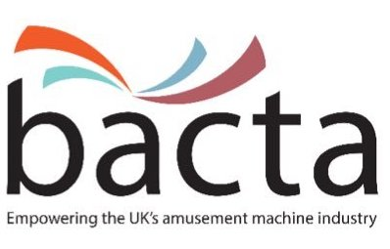
Press Release
Bacta Welcomes Increased Female Representation At Committee Level
Bacta is pleased to announce that four female members have recently been elected into key positions.

Jo Craig from ADP Gauselmann and Jo Fallon of Pontins & Britannia Hotels were elected co-Chairs of bacta’s North West Region a couple of months ago, while more recently, Elizabeth Speed of Luxury Leisure became chair of the Social Responsibility Committee, with Amanda Kiernan of Praesepe taking up the position of Vice Chair.

John White, CEO of bacta commented, “Ours is a traditionally male-dominated industry, however, we have a growing number of women members and it is great to see this group bringing their talents to two key areas of our work.

“Social Responsibility is in our DNA and driving our SR agenda is crucial to the industry’s ultimate success. The Regions provide a direct interface with our members allowing us to communicate what we are doing as well as listening carefully to what our members have to say about their businesses. I hope other women will identify with Liz, Amanda and the two Jo’s and put themselves forward for roles within bacta.”

Elizabeth Speed said, “Being an active member of bacta is important for our wider business. In addition to being a past Chair of Division 3 and a member of Division 1 and National Council, I am pleased to be able to chair the Social Responsibility Committee, which is doing some excellent work in protecting vulnerable players.”

“It’s an honour to be appointed onto the Bacta social responsibility committee. Working with other operators we will collectively work to ensure this committee puts social responsibility and reducing harm to players as our primary objective,” said Amanda Kiernan.

Jo Craig and Jo Fallon said, “There are more women working in the industry than ever before and it is time that this was represented. We enjoy the challenge of co-Chairing the North West Region, liaising with our fellow industry representatives and making a significant challenge to the status quo.”

Editor information:
About bacta:
Bacta represents the owners and operators of seaside amusement arcades, over-18 amusement centres, and the companies that hire machines to pubs, clubs, bowling alleys, bingo halls and similar venues. It also represents the manufacturers and distributors of all types of amusement equipment. This can range from children’s rides, to jukeboxes, fruit machines in pubs and clubs, crane grabbers, penny falls, tuppeny nudgers, test your strength machines, videos, pool tables and gaming machines
www.bacta.org.uk

