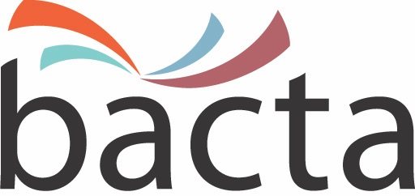 1 February, 2019

Media Enquiries:
John White, CEO
020 7730 6444
07875 687370

Approx Word Count: 300 words

Bacta lead the Social Responsibility debate at third Pub Summit

Social Responsibility (SR) in relation to AWPs in pubs topped the agenda at the third Pub Summit hosted by Bacta and held at ExCeL London on the middle day of EAG.

The Summit attracted double the number of delegates originally anticipated with machine manufacturers, trade bodies, operators and major PubCos including Marston's, Mitchells & Butlers, J D Wetherspoon, Greene King, Star Pubs & Bars and Punch Taverns all represented at the meeting.

Essex Leisure’s Greg Wood, Chair of Bacta Division 2, believes the Summit provides an ideal environment in which to share information, improve knowledge and enhance understanding of SR issues. He said: “The idea behind the Pub Summit is to address key issues of mutual concern and I’m pleased that Bacta members are able to make a full and active contribution bringing their experience of issues such as age verification to the table.”

“In terms of concrete initiatives, we are working with age verification testing company Check Policy which is engaged by Bacta and Reading Local Authority, which is our Primary Authority, to help introduce a robust programme of age verification policies and procedures at the point-of-consumption. In addition, we are developing a programme of online training that Bacta members can offer to their customers and producing a single set of guidance notes in partnership with the British Beer and Pub Association and UK Hospitality. Longer term, we want to be in a position to commission a programme of research into attitudes towards machine playing in pubs.”

The fourth Pub Summit will take place in Summer 2019.

ENDS

About Bacta:
Bacta represents the amusement and gaming machine industry in the UK, encompassing high-tech and creative manufacturers, machine suppliers for pubs, clubs and bingo halls, as well as operators of Family Entertainment Centres and over 18s Gaming Centres. Bacta members include the whole of the amusement machine supply chain in the UK, which has a collective turn-over of nearly £2bn across more than 500 companies, operating in excess of 310,000 machines.

