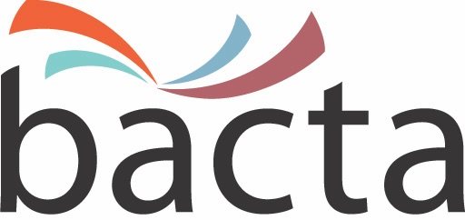 19 December 2017

Media Enquiries:
John White, CEO
020 7730 6444
07875 687370

Approx Word Count: 235 words

Bacta confirm first EAG Dinner is sold out

Bacta has been forced to post the sold out signs following what it is describing as a ‘hugely encouraging’ response to its first EAG dinner which is taking place on the Tuesday night of what is the industry’s showpiece UK event. The dinner, which is being held on the Sunborn Super-Yacht hotel situated in Royal Victoria Dock, less than a minute’s walk from ExCeL London, has a capacity of 120 people.

John White, CEO of Bacta, believes the rapid take up of tickets augurs well not only for the 2018 edition of EAG, but for the industry as whole. He said: “EAG sets the tone for the year ahead and I am encouraged at how quickly the EAG Dinner has sold out. Our first offering was to Bacta member exhibitors who snapped up the full availability. The Sunborn is a fantastic luxury venue but the capacity is slightly limiting. If the response to this latest Bacta initiative is positive it could well open up the possibility of reintroducing the Bacta Ball which in its prime was a fantastic celebration of our industry, the perfect social accompaniment to three days of hard business and, it should be said, a great source of funds for the Bacta Charitable Trust.

“From my discussions with Bacta members there is a great deal of optimism surrounding EAG 2018 and I look forward to welcoming the industry to ExCeL in January."

ENDS

Image:
John White, CEO of Bacta

About bacta:
Bacta represents the amusement and gaming machine industry in the UK, encompassing high-tech and creative manufacturers, machine suppliers for pubs, clubs and bingo halls, as well as operators of Family Entertainment Centres and over 18s Gaming Centres. Bacta members include the whole of the amusement machine supply chain in the UK, which has a collective turnover of nearly £2bn across more than 500 companies, operating in excess of 310,000 machines.

